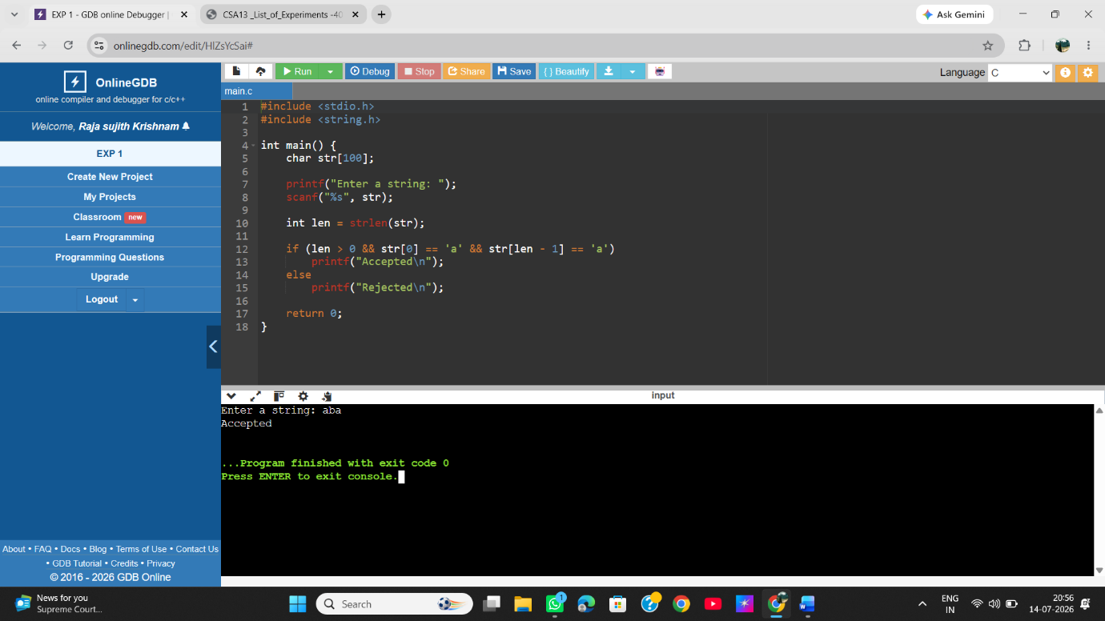
EXP 1 :- Write a C program to simulate a Deterministic Finite Automata (DFA) for the given language representing strings that start with a and end with a

